

**STANDARD OPERATING PROCEDURE**

**Do not Photocopy**

**Document Information Classification: Unrestricted**

|  |  |
| --- | --- |
| **Title:** | **Maintaining Person Records** |
| **Effective Date:** | **09 May 2019** |
| **Reference Number:** | **SOP-01-04** |
| **Version Number:** | **1.4** |
| **Owner:** | **Staff Management Process Owner,** |
| **Review Date:** | **09 May 2021** |

Table of Contents

1. Purpose 3

2. Scope 3

3. Responsibilities 3

4. Procedure 3

4.1. Updating Person Records 3

4.2. Location Changes 4

4.3. Extended Absence 4

5. Cross-referenced ISMS Documents 4

6. Appendices 5

6.1. Q-Pulse Guidelines for Managing People Records 5

6.1.1. Updating Details 5

6.1.2. Adding a Note 6

6.1.3. Deleting a Note 6

6.1.4. Adding File Attachments 8

1. Purpose

It is a requirement of the ISMS that all employees of the organization should be identified and a person record should be created and maintained. This document describes the procedures to be followed to ensure the Q-Pulse person information is accurate and that only active members of CHI are included in routine ISMS monitoring and measurement.

1. Scope

All people that have an active employee account registered on Q-Pulse.

This procedure includes for the management of Q-Pulse organisational changes, person detail changes including existing members of CHI who relocate to a different building or within a building and managing Q-Pulse access for users on long term leave.

Changes to personnel details managed by the University or Faculty are out of scope of this procedure.

1. Responsibilities

CHI Staff Administration is responsible for:

* Updating person records in Q-Pulse

The Q-Pulse Administrator is responsible for:

* Enabling and disabling Q-Pulse user accounts
* Updating the Q-Pulse ‘Organisation’ managed list
* Updating document distribution lists

The Line Manager is responsible for:

* Informing CHI Staff Administration of employee changes
* Arranging the appropriate building induction to support location changes

1. Procedure
   1. Updating Person Records

The Line Manager will inform CHI Staff Administration (xxxxxxxxx) of any changes in the details of the employees reporting to them. This will include changes to:

* Name
* Job Title
* Department
* eMail address
* Line Manager
* Location

CHI Staff Administration will update the details for the person in Q-Pulse.

If the department details are not present in the Q-Pulse ‘Dept.’ drop-down, CHI Staff Administration will inform the Q-Pulse Administrator who will update the Q-Pulse ‘Organisation’ managed list accordingly.

If the person’s role has changed the Q-Pulse Administrator will add or remove the person from the distribution lists for ISMS documents as necessary for their new role.

Documents can also be attached to the person record e.g. completed forms FORM-004, FORM-005. These documents can be attached by the Line Manager or CHI Staff Administration.

* 1. Location Changes

For a change of location CHI Staff Administration will also ensure that any assets are updated to reflect the change (SOP-05-02 Return, Re-use and Disposal of TRE Assets).

For a move to a new building the Line Manager will arrange a short introduction to ensure that the employee is aware of the health and safety and operational aspects of the new location (see ISMS-01-04). This will not be recorded.

* 1. Extended Absence

Extended absence from CHI may be due to a number of reasons including:

* Career break
* Long term sickness
* Maternity leave
* Secondment
* Working away from CHI

Where the duration of this absence is expected to be greater than 3 months the Line Manager will inform CHI Staff Administration who will add a Note to the person record in Q-Pulse to allow this absence to be tracked and the person excluded from routine monitoring and measurements. To assist with reporting the Note should be prefixed with the phrase “Extended absence - ….” e.g. Extended absence – Secondment.

On return from absence the Line Manager will inform CHI Staff Administration who will add a new note on Q-Pulse to confirm the person’s return.

1. Cross-referenced ISMS Documents

|  |  |  |
| --- | --- | --- |
| Number | Type | Title |
| SOP-05-02 | ISMS\SOP\Asset and Supplier Management - SOP | Return, Re-use and Disposal of TRE Assets |
| ISMS-01-04 | ISMS\Policy & Guidance\Personnel & Training - policy & guidance | Guidance for new CHI staff and students |

1. Appendices
   1. Q-Pulse Guidelines for Managing People Records

This section details the Q-Pulse specific guidelines for updating person details, adding and deleting notes associated with a person record and adding file attachments.

The People and TRE User Accounts List is accessed from the Q-Pulse Launchpad

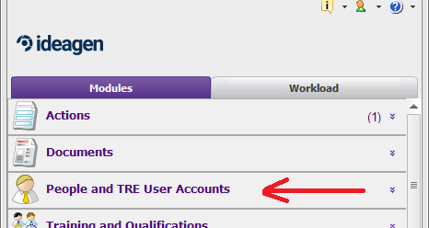

* + 1. Updating Details
* To update the account details for a person, access the person’s record from the People and TRE User Accounts List

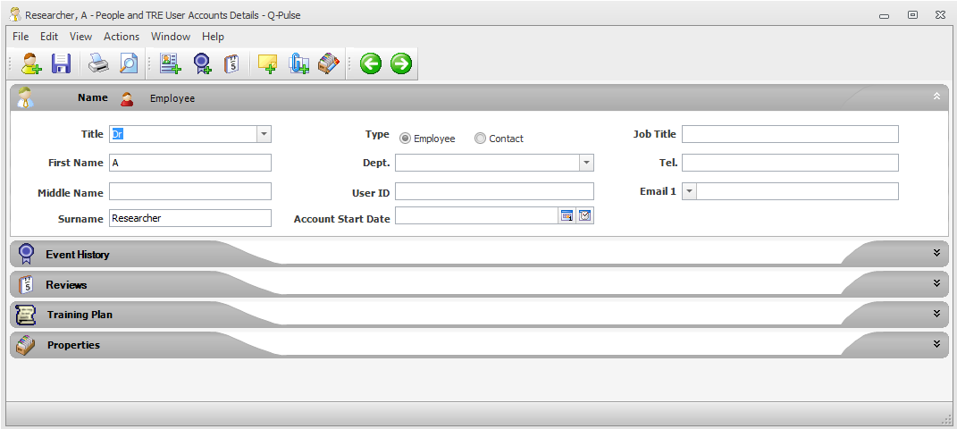

* Update the details as necessary and save the person record by clicking on the Save  icon
  + 1. Adding a Note
* Notes will be used, in particular, to indicate periods of extended absence. The notes are access through the Properties tab on the person record

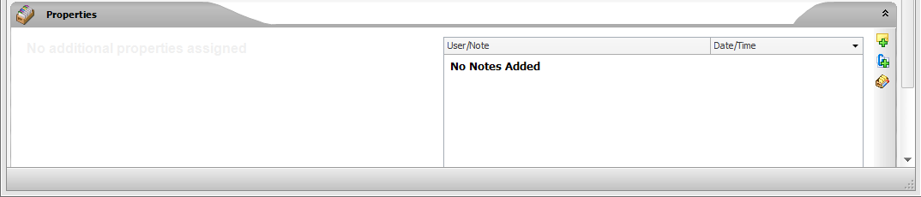

* To add a note click on the Add note  icon

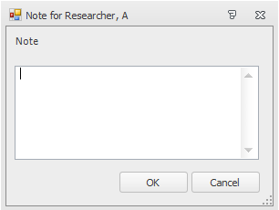

* Enter the details for the note e.g. Extended absence - sickness
* To save the note click OK and then save the person record
  + 1. Deleting a Note

Open the Properties tab and click on the icon to display the Person Properties window

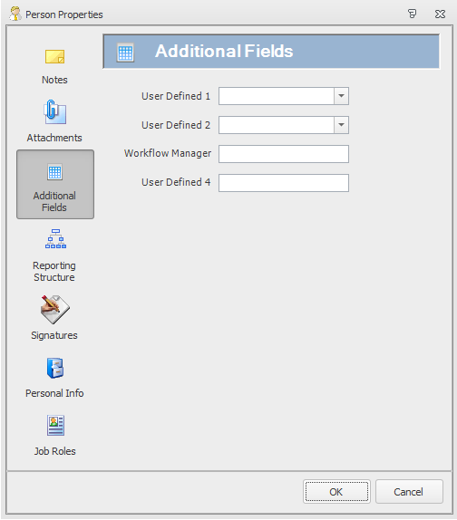

* To access the notes click on the Notes icon



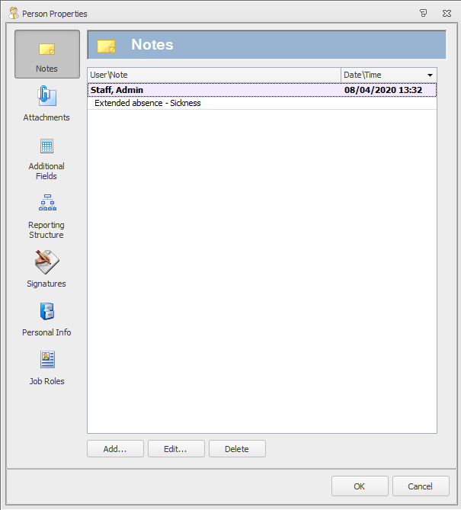

* Select the note you want to delete and click the ‘Delete’ button.
* Click on OK and save the person record.
  + 1. Adding File Attachments
* Access the person record from the ‘People and TRE User Accounts’ module.
* Click on the menu bar item Actions -> Add Attachment

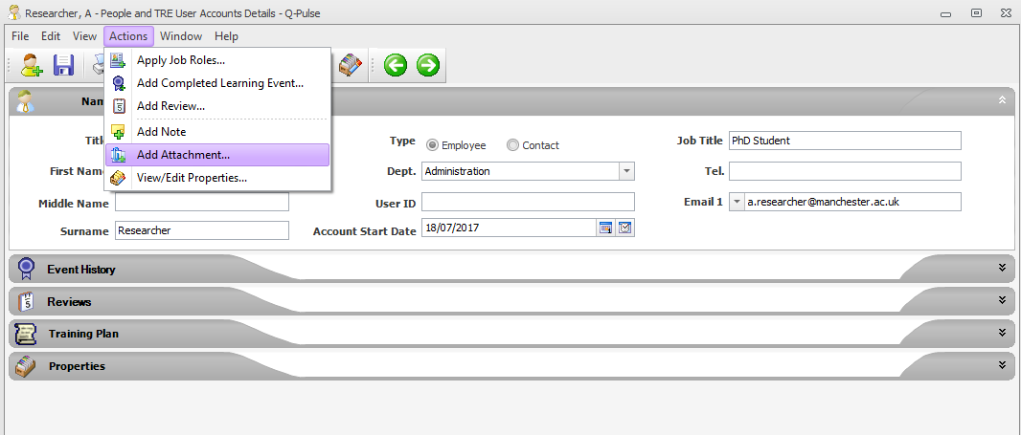

* This displays the ‘Edit Attachment’ dialog.
* Note: this option will not be available if the person record selected is not set within the Q-Pulse reporting structure as being line managed by you.

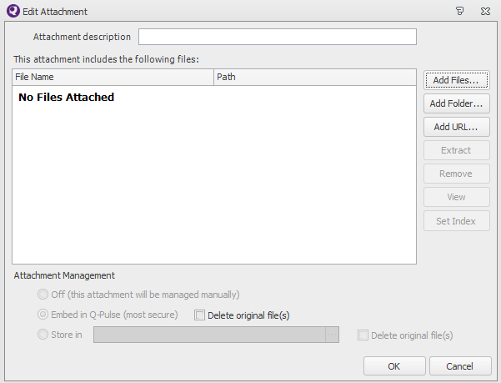

* Click on the  button to display windows explorer where the file to be attached can be located and selected.
* Note: any format of file type can be attached e.g. a Word document (.docx) or a scanned image (.pdf). The file must be closed before it can be attached to Q-Pulse.
* After the file has been selected click on ‘OK’ and save the person record.